Source Code Outlining

CONTROLLER

#1 Prepared a dictionary in which will be used to take the words of the number.

\* 1 - 19 & 20 – 90 (in tens)

Reasons: Use dictionary easy to compare and refer, instead of using list.

#2 Main function when click the button. Get the number -> Split the number into 2 parts (round number & decimal) -> Convert each part -> Pass the words into string

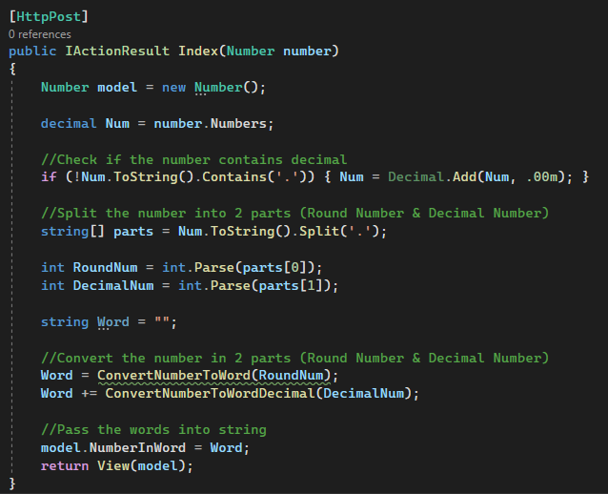Reasons: All the main flow in this function so that easy to debug & check, since it is a straightforward function.

#3 Convert round number function. To check if the number is in millions or thousands. Each part will convert the number in hundreds, tens & ones (ConvertNumberToWordBased function).

Reason: Much more clean to understand the logic.

#4 Convert decimal number function. Will only convert decimal part in tens & ones.

Reason: Short and completed.

#5 Convert Hundreds, Tens, Ones to words.

Reason: Write this in separate function because it will be used multiple times the program.

MODEL

Declare all the properties: Number & Word

VIEW

Display the data and Integrate with the models.